

| Course Number | COE328 |
| --- | --- |
| Course Title | Digital Systems - F2022 |
| Semester/Year | Fall 2022 |
| Instructor | Shazzat Hossain |
| TA Name | Sajjad |

| Lab/Tutorial Report No. | Lab 4 |
| --- | --- |

| Report Title | **VHDL for combined Circuits and Storage Elements** |
| --- | --- |

| Section No. | 11 |
| --- | --- |
| Group No. | N/A |
| Submission Date | Oct 20, 2022, |
| Due Date | Oct 20, 2022 |

| Student Name | Student ID | Signature* |
| --- | --- | --- |
| Hamza Malik | 501112545 | Hamza Malik |

*\*By signing above you attest that you have contributed to this submission and confirm that all work you have contributed to this submission is your own work. Any suspicion of copying or plagiarism in this work will result in an investigation of Academic Misconduct and may result in a “0” on the work, an “F” in the course, or possibly more severe penalties, as well as a Disciplinary Notice on your academic record under the Student Code of Academic Conduct, which can be found online at:*

[*http://www.ryerson.ca/content/dam/senate/policies/pol60.pdf*](http://www.ryerson.ca/content/dam/senate/policies/pol60.pdf)

Encode. vhd mux.vhd 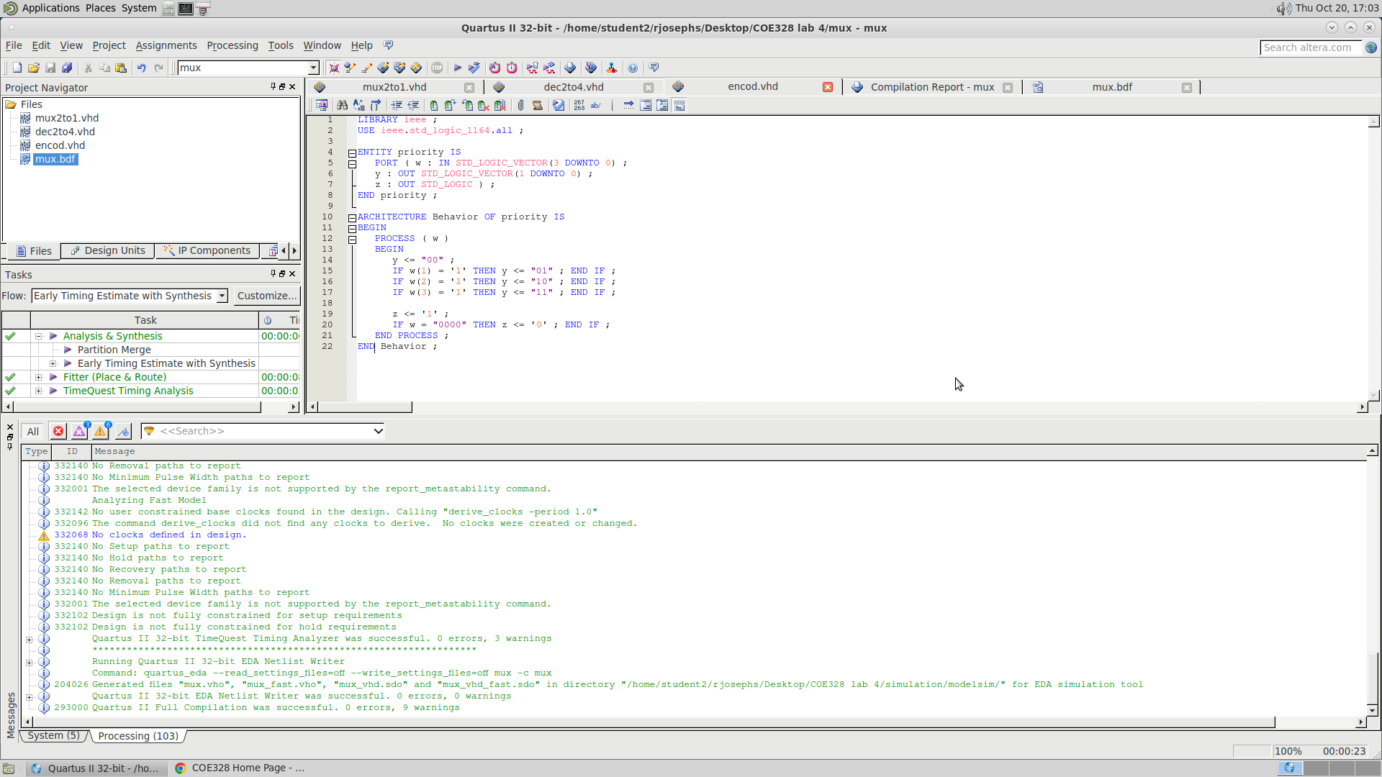

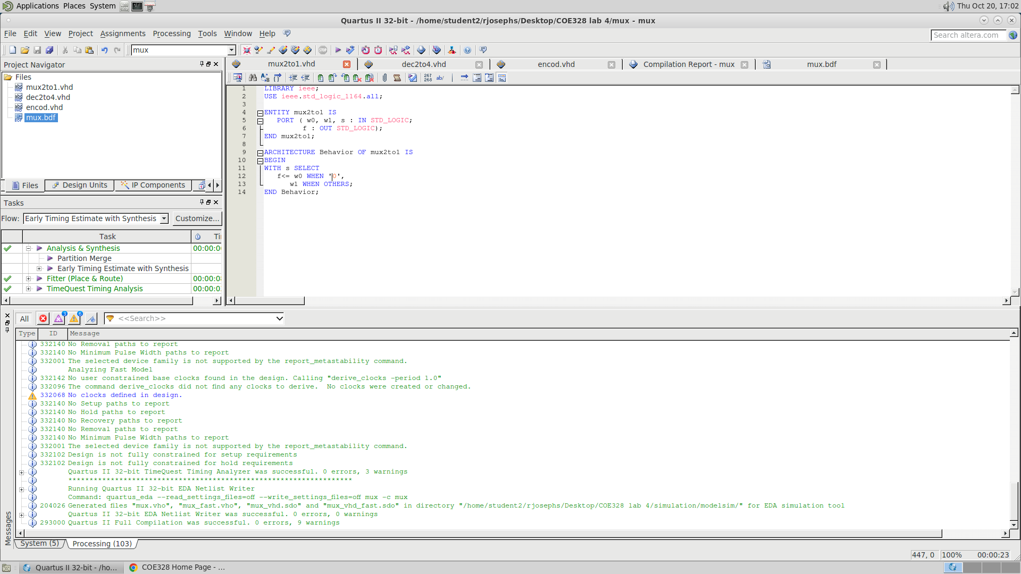

Decode.vhd

